ITECA3-B12

User Manual | Guillaume van der Vyver FSWSC4227

Question 3

3.1.1 Background

An E-Commerce Health Shop with many supplements along with a blog section that gives helpful health tips and tricks.

3.1.2 About this website

In this website, I made Use of HTML for the base of the website and CSS for the styling and making everything look nice and move smoothly when transitioning to the next page.

I also made Use of jQuery for a slider and combo’d that with JavaScript to make to move automatically. Javascript was also used in the bootstrap sections along with my sessions that were used to make the session register the user that has logged on.

And then for the back bone of the website. PHP I used php for all the functionality of the website along with the database integration. The database management software that is used is SQL and used MySql Workbench for this.

3.2 Basics: Accessing your website and Admin

3.2.1 Accessing website



On the Image you can see there is a Login, Sign-up and Admin section.

The user has 2 options the access the website.  
Either Create a new account or login in he already had one.  
  
Register page look as follows:

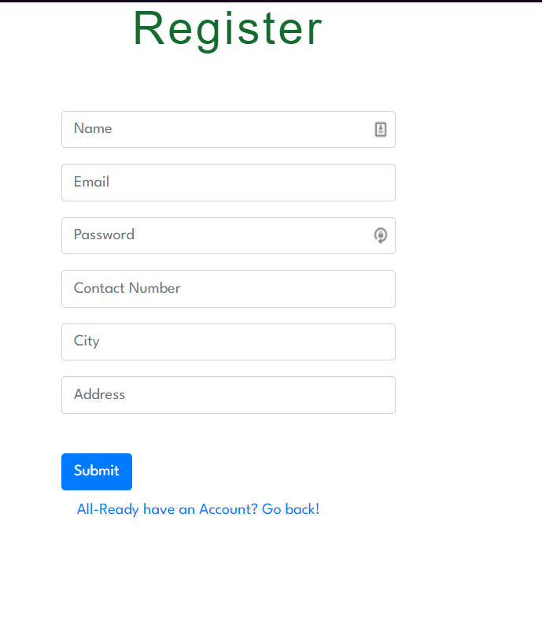

All the fields are required. To be able to submit and create your own account. If the user realises, they already have one they can just click on the go back button and head back to the home page to login.  
  
Once they do Successfully register themselves, they will be sent to the Shop page where they can then proceed to buy items.

If the user does decide to head back because they have and account, they can then login to access the website:

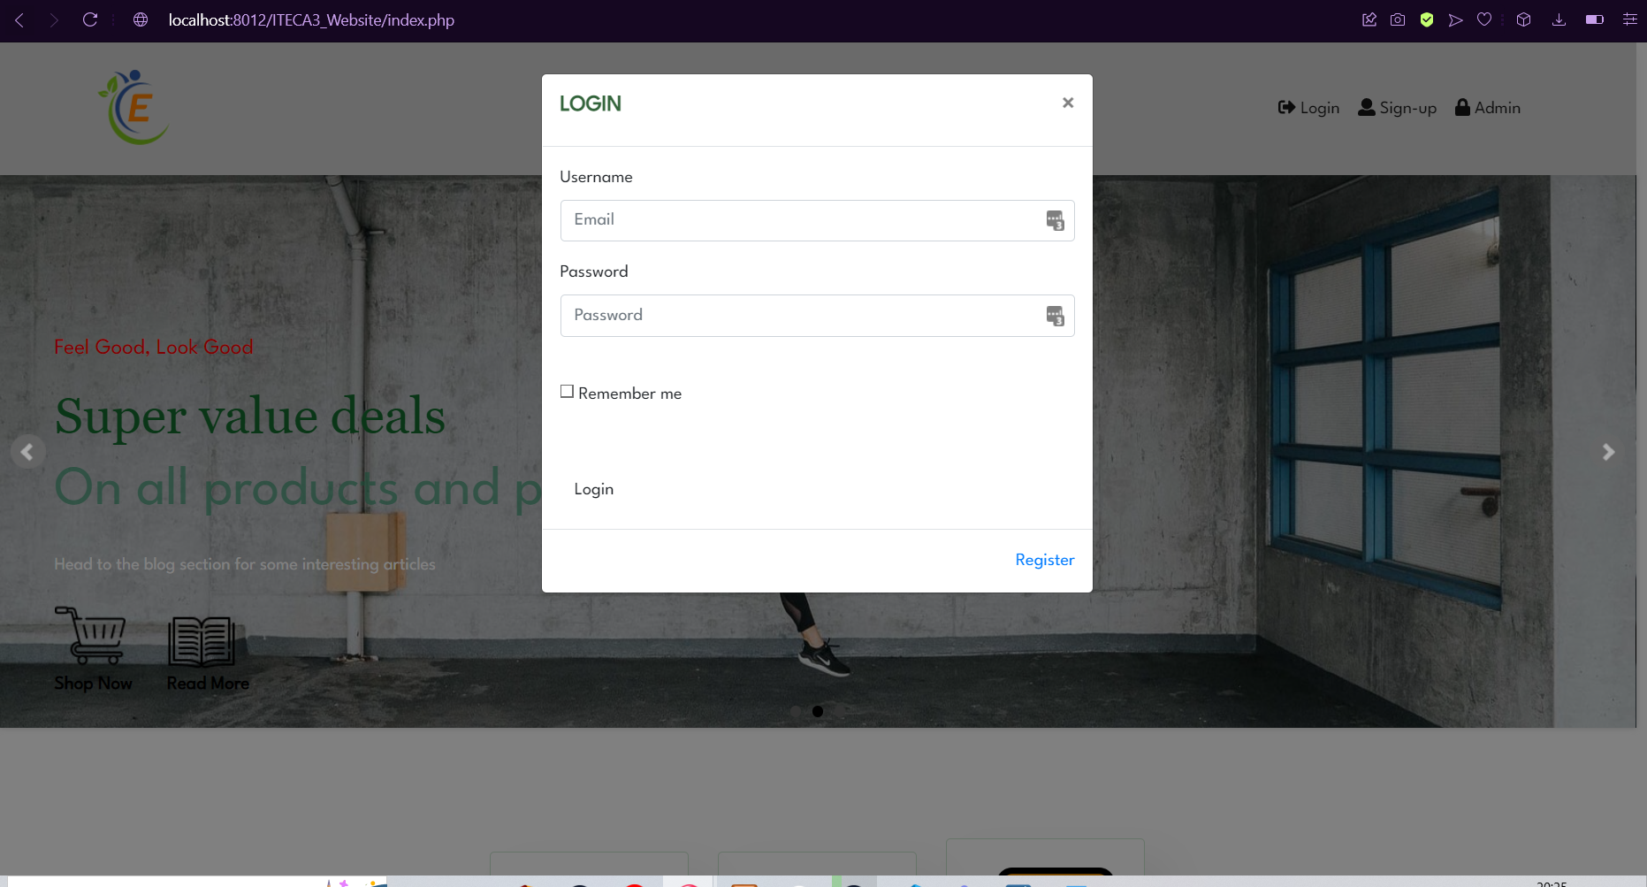

The login screen will pop-up and require you to input your personal account information. There is also the Register option if you don’t have an account.

And if you wanted access to the admin section you will have to login at the admin option looking as follow:

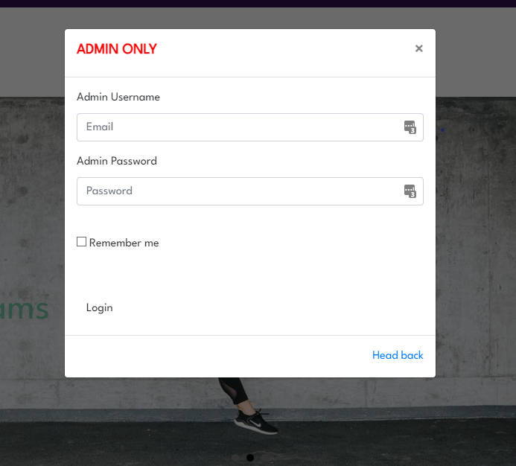

## 3.2.2 Admin Area

For the Admin panel, you can only gain access here after you have entered you admin email and password into the admin login. After that you will be send to the admin panel:

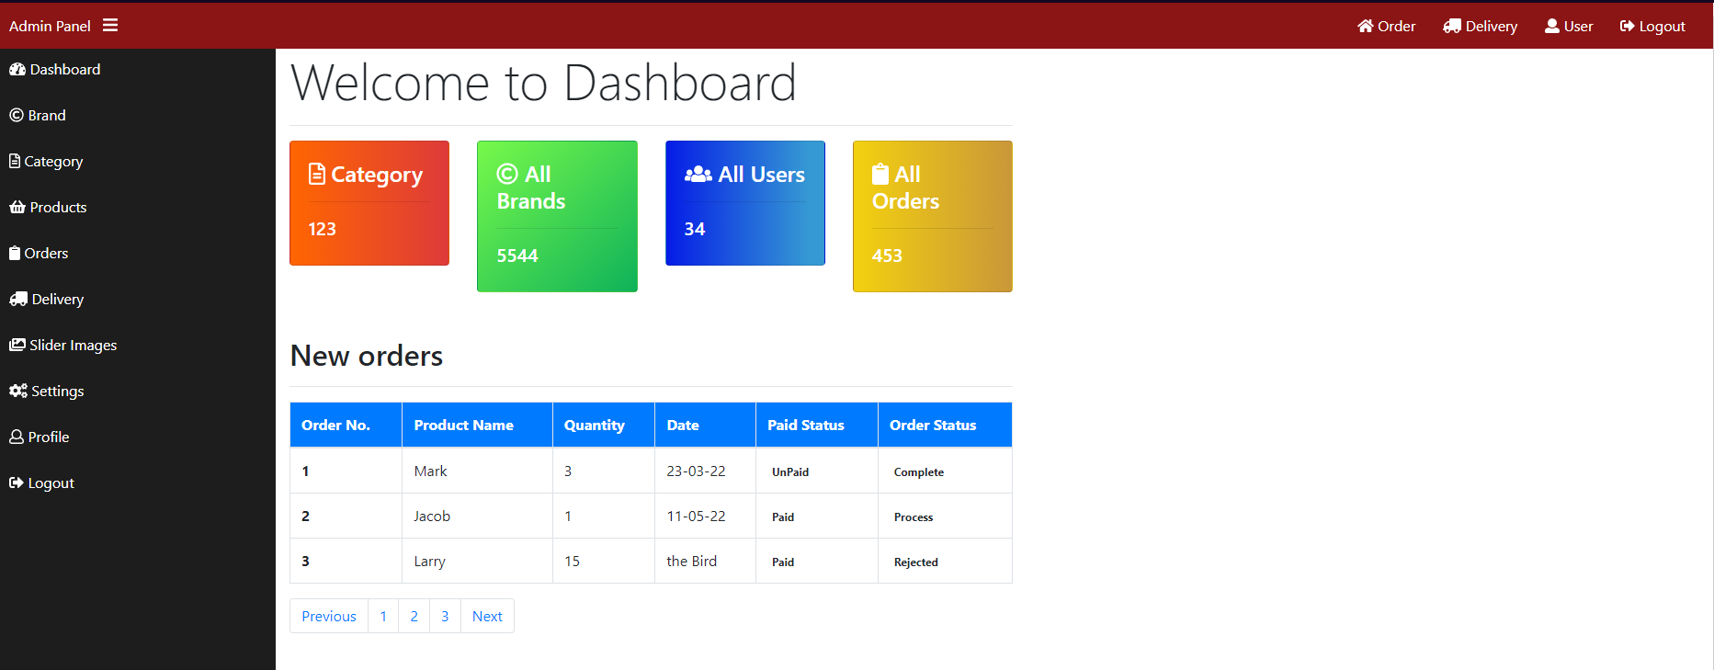

The admin panel is where all the site actions are controlled as you can see there is various actions that can be done on the admin panel. At the dash board you see how many users there are, how many orders, amount of brand and how many catagories.

3.3 Products: Adding, removing and updating products

3.3.1 Adding and Removing products

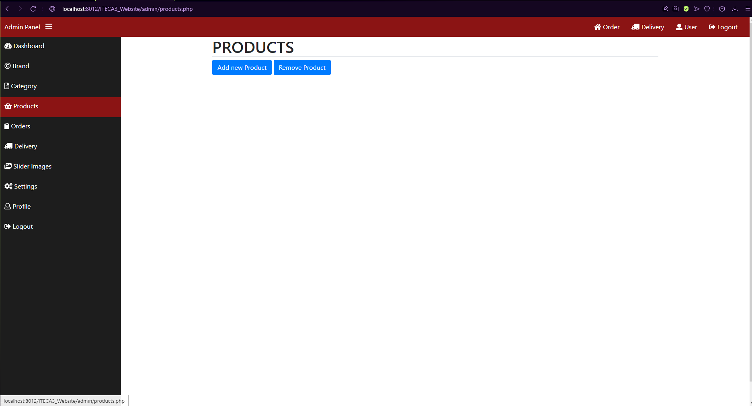

To add and remove products you must click on the products tab on the left and this screen will be displayed. You can then either click add new product or remove Product each looking as follow:

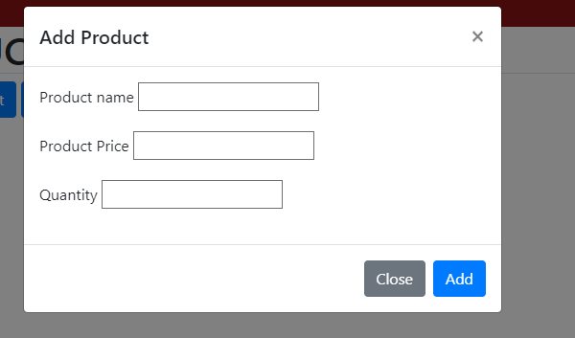

Add a product by entering the name, price and quantity and pressing Add.

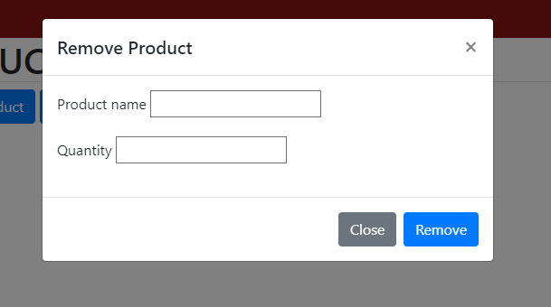

Remove a product by entering the name and how much should be removed.

3.5 Shipping Options

My website has a delivery section that shows how many deliveries are due:

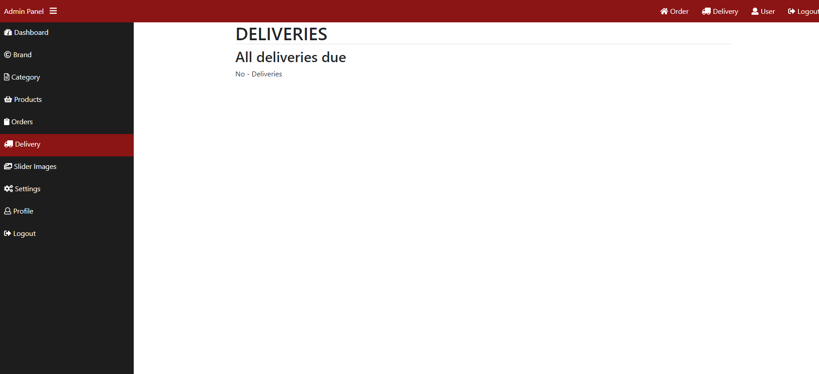

3.6 The front page: adding and changing images

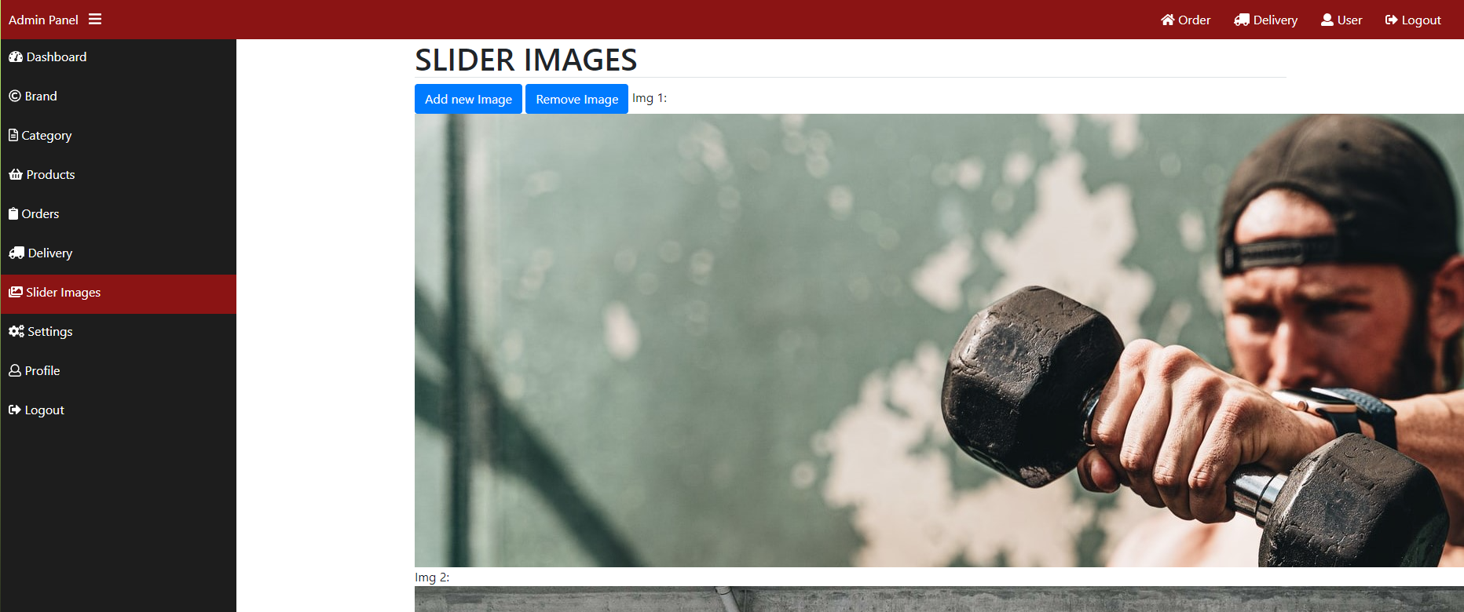

Here the Slider images on the home page can be added and removed from the slider.

To add you just remove slider1.jpg and add a new slider1.jpg

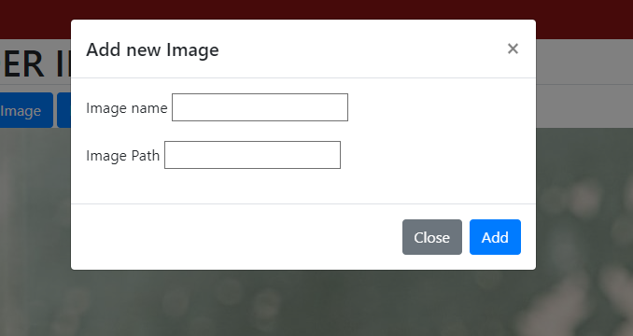

To add new images

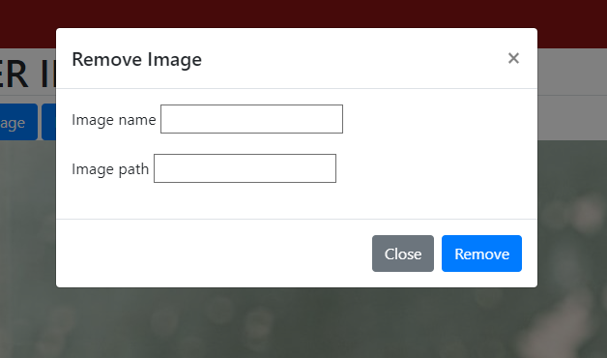

To remove the slider images.

3.10 Collecting money from the store

When successfully logged in the side will take you to the shopping area:

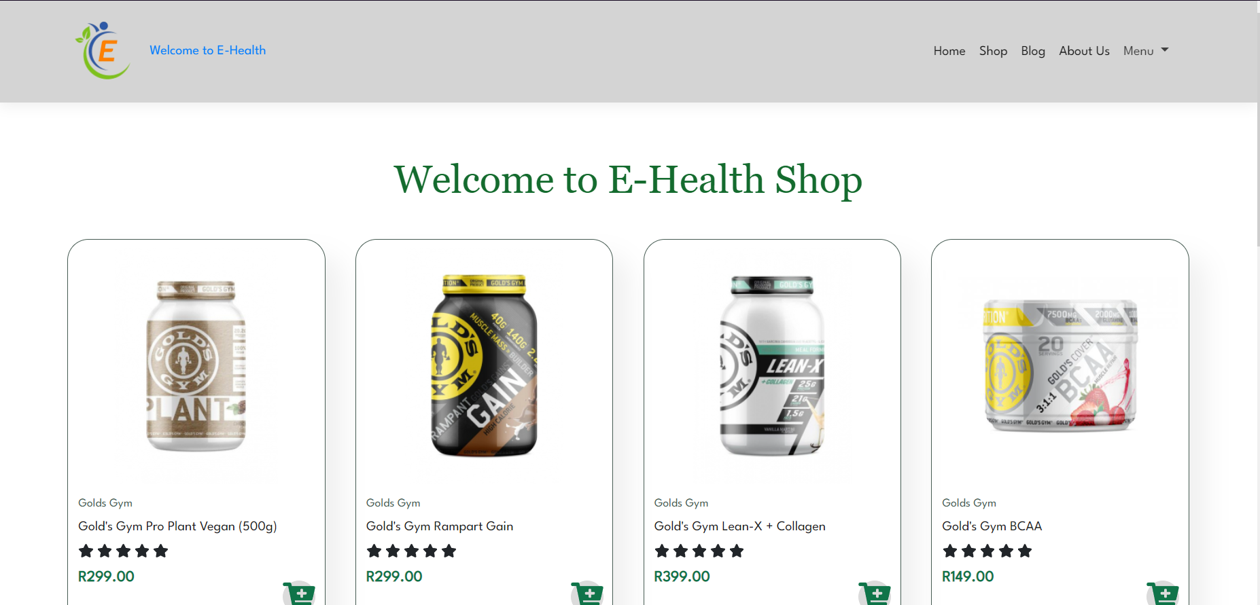

In the shopping cart section, there is a collection of supplements they user can choose from. When you click on the cart + button the item will be added to your cart. All items will be added there and the user can access this at the top of the page. The user will see the Navbar filled with a couple o places to visit. Either the blog section or about us. Then there is also the menu drop down that will give you 2 options: 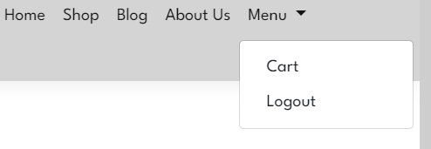

You can head to the cart section or you can end you visit and Logout.

Going to the cart section this is where you can confirm your order and check out.

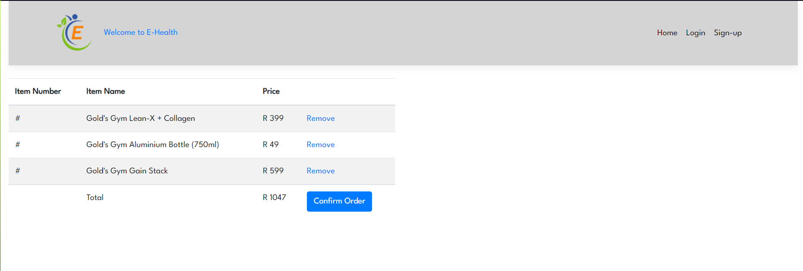

Here you can see the cart if items that was added by clicking on add from the website. When you press on confirm order the items will check out and allow for payment.

## Payment Options:

EFT directly into bank account.  
Pay fast integration

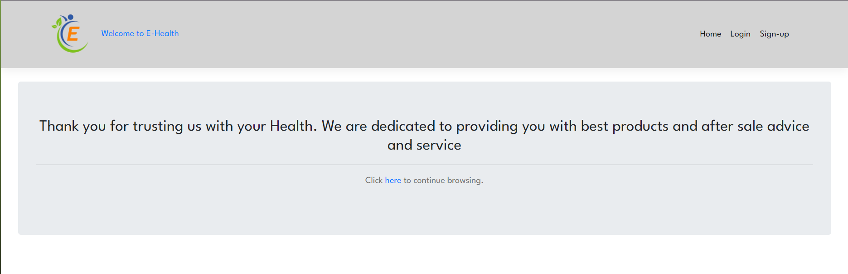

This is after check out the website will ask if you want to continue shopping and will allow for redirection back to the home page.

3.12 Appendix

To be able to run the program you must do the following:  
  
Programs needed to run it:  
XAMPP – This is needed to access the website.   
My SQL Workbench – this is needed to be able to access the database and use all the content.

## How to run my website:

Install and Open up XAMPP – Copy my assignment file into XAMPP/HTdocs

Open XAMMP as admin and start both Apache and MySQL

Import the SQL files into Mysql work bench.

Then to see and start using the website type into your url search bar: 